Writing Guidelines and Instructions for Submission of Articles in the Jurnal Geosains dan Remote Sensing (Arial 14pt Bold)

First Author Name^{1*}, Second Author Name² , Third Author Name^{1, 2} (10pt bold)

¹Affiliation, address, write down the affiliation and address in full, including country and postal code (8pt italic)
²Added according to the number of author affiliations

Received:  Revised:  Accepted:  *Correspondent Email:  author@email.id   | Abstract: The title, formulated briefly and clearly, is written in Arial, 14pt, bold, 1 space, middle margin, capital letters, and a maximum of 20 words. The latest topic or is the result of research. The authors' names are all without titles, written in Arial, 10pt, bold, middle margin. The institution's name in the second line is in the order of the author's institution, written in Arial letter, italic, 8pt, middle margin. The author's institution address is in the third line. The writing of the second identity and so on is the same as the first writer. Abstract manuscripts written in Arial, italic, 9pt, 1 space, maximum of 200 words. If the article is in Indonesian, the abstract must be written in Indonesian and good English. If the article is in English, then the abstract must be written in English only. The abstract must be concise and contain the core of the problem to be raised, the objectives, the method of its resolution, the results of scientific findings obtained, and conclusions. Abstracts for each language should only be written in one paragraph with one column format. Keywords are written in Arial, 9pt, bold, and italic.  Keywords: article; geoscience; remote sensing; unila; writing instructions

1. PENDAHULUAN
Scientific articles are written in 2-column format with the letters Arial, size 10, 1-spaced on A4 paper, with left margins of 2.5 cm, right 2 cm, top 2 cm, and bottom 2 cm with a maximum number of pages of 10 pages. The introduction contains the background of the problem, which is supported by concepts, theories, and research results from relevant and up-to-date literature sources. End with a clear purpose for writing articles or research. Articles published in JGRS are original scientific research results, a priority, and scientific review articles, which are also considered. JGRS accepts manuscripts or articles in geoscience and remote sensing. The scope of published research topics is part of the field of geoscience, including Geology, Geophysics, Remote Sensing, Exploration of Natural Resources (Oil and Gas, Minerals and Coal), Geothermal and Geological Disaster Mitigation (Volcanoes, Earthquakes and Tsunamis, Landslides, Subsidences etc.) (Yudhicara et al., 2017).
Articles that will be published in JGRS have gone through a review process by the reviewer with a blind review system. The decision whether or not to accept an article submitted to JGRS is the full right of the editorial board based on the recommendation of reviewers and the consideration of the chief editor. Provisions related to plagiarism, copyright infringement, and defamation are included in the guidelines provided on the https://jgrs.eng.unila.ac.id page. In making decisions, the editors will confer with the parties. The editor evaluates manuscripts regardless of ethnicity, race, religion, gender, nationality, and other matters contrary to humanitarian principles.
The description presented in the introductory section includes the importance of the study being carried out with the support of several good references. Citations from references from the last 5-10 years are preferred so that contributions to the research presented in this paper are obtained.

2. MATERIALS AND METHODS
This chapter explains the tools and materials used and the standard data collection and representation methods. Also explained are various formulas or scientific formulas, qualitative and/or quantitative data descriptions, data collection procedures, and data analysis procedures. Describe the types of tools and basic materials specifically. Also, explain the process of acquisition, processing and analyzing the data obtained and drawing conclusions.
Materials and Methods contains the primary materials used in research and the methods used to solve problems, including analytical methods. The main tool series should be presented in this section, accompanied by an image description. Image captions are placed as part of the image title (figure caption) and not as part of the image (Figure 1). The methods used in completing the research are written in this section. Area studies can also be presented in a study if the research is related to using geospatial data and information in the form of an image. Apart from that, the display of images must be authentic results of the work of researchers and not taken from the work of other researchers. If it has to be done like that, it requires written permission from the owner of the image.
Using figures in the form of maps is recommended not to use legends or other cartographic components separately from the main map. But it must be on the main map (Figure 1).

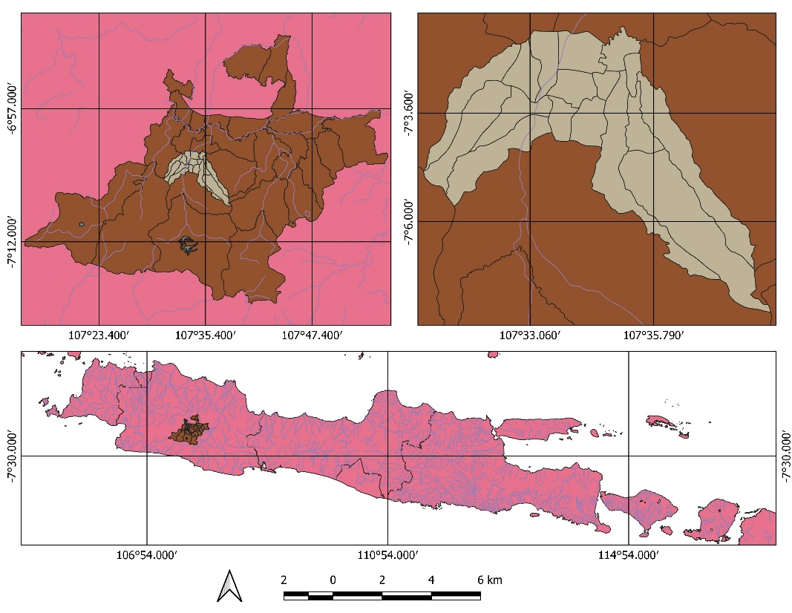
Figure 1. Images can be positioned in one column if they are large. In contrast, small images can be entered in the same column as the text. Images and titles are centered, while image titles follow the justified format if more than 1 line.

2.1. Writing Title, Name, and Address of Author
For writing the author's name (without an academic degree) and the address of the author's affiliation it is written in the middle on the first page below the article title. The distance between the lines between the title and the author's name is 2 spaces, while the distance between the address of the author's affiliation and the author's name is 1 space. Keywords must be written below the abstract text for each language, arranged alphabetically, and separated by semicolons with a word count of 5 words. For articles written in Indonesian, write the translation of the title in English at the beginning of the abstract in English (see example above).
The article's title must be written briefly and clearly and indicate the problem to be raised, not allowing for various interpretations, written in capital letters at the beginning of each word symmetrically. The article's title must not contain abbreviations that are not commonly used. State the main idea of the new article first, followed by other explanations.
Responsible author, correspondence author, or corresponding author must be marked with a superscript asterisk “ * ”. You must write the correspondence email address in the left column of the first page/abstract. Communications regarding article revisions and final decisions will only be communicated via the Corresponding Author's email. If there is more than one author, write the authors' names separated by a comma (,). If the author's name consists of two or more words, the first word of the author (first name) should not be abbreviated. If the author's name consists of only one word, write the real name in one word. However, in the online version (HTML), it will be written in two words containing the same name (repeat) for metadata indexation purposes. If the authors come from different affiliations, the author's name and affiliation are connected by a superscript number “ ¹ ”, as in the example above.

2.2 General Instructions for Writing Manuscripts
Article manuscripts that meet the JGRS writing guidelines (in MS Word format, use this article template) must be submitted online using the online system at the Open Journal System portal (https://jgrs.eng.unila.ac.id/index.php/geo) by registering as an Author in the "Register" section first. Article manuscripts that do not comply with the JGRS writing guidelines will be returned to the author before proceeding with the review process.
The manuscript of the article written must contain the following components in the scientific article (subheadings in order), namely: (a) Title of Article, (b) Name of Author (without title), (c) Address of Author Affiliation, (d) Abstract and Keywords, (e) Introduction, (f) Materials and Methods, (g) Results and Discussion, (h) Conclusions, (i) Acknowledgments, and (j) Bibliography. Writing subtitles in the article's contents (Introduction, Materials and Methods, Results and Discussion, Conclusions) must be numbered sequentially in Arabic numeral format starting from number one. Subtitles are written in bold with the Capital Case format and aligned to the left without underlining. Sub-titles are written in bold with the Title Case format and aligned to the left and use the second-level numbering format.
Manuscripts can be written in Indonesian or English with a minimum number of pages of 7 pages and a maximum of 15 pages, including figures and tables. Manuscripts must be written according to the template of this article in print-ready form (Camera Ready). Manuscripts must be written in Arial font with a font size of 10pt (except for article titles, author names, and abstract titles), single space, and in two-column format (except for the article title, author name, and abstract and large images). The distance between the columns is 5 mm.
Foreign words or terms are used in italics. It is better to avoid using foreign terms for articles in Indonesian. New paragraphs start 10 mm from the left border, with no space between paragraphs. All numbers are written in Arabic numerals, except at the beginning of the sentence. Tables and Figures are placed in the text group after the table or figure is referred to. Each image must be given the title of the image below the image and numbered in Arabic numerals followed by the image title. Each table must be given a table title and numbered in Arabic numerals above the table, followed by the table title. Images must be guaranteed to print clearly (font size, resolution, and line size must be sure to print clearly). Figures, tables, and diagrams/schematics should be placed according to columns between groups of text or, if they are too large, placed in the middle of the page. Tables may not contain vertical lines, while horizontal lines are allowed only in column headings and the table's last row (Table 1).

Table 1. Acquisition parameters in the field
Measurement Parameters | Value
Time | ± 30 minutes
Sampling Rate | 500 SPS
Sampling Period | 0.002 seconds
Number of Axis | 3
Number of Measurement Points | 30

3. Results and Discussions
Results and discussion contain the results of research findings and scientific discussion. Write down scientific findings (scientific findings) obtained from the research results that have been done but must be supported by adequate data. Conclusions describe the answers to the hypotheses and/or research objectives or scientific findings obtained. The conclusion does not contain a repetition of the results and discussion but rather a summary of the findings as expected in the objectives or hypotheses and the things that will be done related to the next idea of the research.
All references referred to in the text of the article must be listed in the Bibliography section. The bibliography must contain reference libraries originating from primary sources (scientific journals and a minimum of 80% of the entire bibliography) published in the last 10 (ten) years. Each article contains at least 12 (twelve) references. Writing a reference system in the text of the article and writing a bibliography must use a reference management application program such as Mendeley (Kemp & Telford, 2015).

3.1 Equation Writing Guide
Each equation is written justified in the middle of the column and is numbered in brackets, and placed at the end of the right margin. Equations must be written using the Equation Editor in MS Word or Open Office (Telford et al., 1990).

$\oint{B.ds=μ_{0}I+ε_{0}μ_{0}\frac{{dΦ}_{E}}{dt}}$ (1)

3.2 Guidelines for Writing Quotations in Text Articles
The author must write down the reference source when taking data or quoting statements from other literature. References or citations are written in the description/text through the author's name and year (Sarkowi, 2014). If there are more than two authors, only the first author's name is written, followed by "et al." (Darmawan et al., 2015). Everything referred to in the text must be listed in the Bibliography section, and vice versa, everything written in the Bibliography must be referred to in the text. If there is more than one reference, they are separated by a semicolon and sorted alphabetically (Kippenberg, 2004; Putra et al., 2016; Zaenudin et al., 2018).

4. CONCLUSIONS
Conclusions describe the answers to the hypotheses and/or research objectives or scientific findings obtained. The conclusion does not contain a repetition of the results and discussion but rather a summary of the findings as expected in the objectives or hypotheses and the things that will be done related to the next idea of the research.
Manuscripts are submitted fully online to the JGRS online journal system portal at: (https://jgrs.eng.unila.ac.id/index.php/geo) with the following steps:

1. Authors register as Authors and/or Reviewers (tick the role as Author and/or Reviewer) in the "Register" section: https://jgrs.eng.unila.ac.id/index.php/geo/user/register
2. Author login as Author, click on "New Submission". The stages of submitting articles consist of 5 stages, namely: (1). Start, (2). Upload Submission, (3). Enter Metadata, (4). confirmation
3. select Submission Language (English or Indonesian) in the Start section and check all the checklists.
4. In the Upload Submission section, please upload the article manuscript file in MS Word as well as all the required Supplementary Files in this section.
5. In the Enter Metadata section, enter the title and abstract, list of contributors (write down all the authors and specify the corresponding author), keywords and bibliography.
6. In the Confirmation section, please click "Finish Submission" if all data is correct.
8. If the author has difficulties in the process of submitting the manuscript, please consult via email to the JGRS Editorial email (jgrs@eng.unila.ac.id).

Every article submitted to JGRS must follow these writing guidelines. Articles that do not comply with these guidelines will be returned prior to further review.

ACKNOWLEDGMENTS
Acknowledgments are addressed to research funders, donors, and parties who assist in research. The thank you subtitles are not numbered.

REFERENCES
Bibliography writing should use a reference management application. The writing format used in JGRS is according to APA 7th Edition (American Psychological Association) format.
References in scientific journals:
Yudhicara, Muslim, D., & Sudradjat, A. (2017). Geomorphic analysis in determining tectonic activity affected by Sumatra Fault in Liwa region and its surrounding area, Lampung, Indonesia. Indonesian Journal on Geoscience, 4(3), 193–208. https://doi.org/10.17014/ijog.4.3.193-208
Zaenudin, A., Darmawan, I. G. B., Armijon, Minardi, S., & Haerudin, N. (2018). Land subsidence analysis in Bandar Lampung City based on InSAR. Journal of Physics: Conference Series. https://doi.org/10.1088/1742-6596/1080/1/012043
References in Books:
Sarkowi, M. (2014). Gravity Exploration. Yogyakarta, Indonesia: Graha Ilmu.
Telford, W. M., Geldart, L. P., & Sheriff, R. E. (1990). Applied geophysics, 2nd edition. 2nd edition. New York, USA: Cambridge University Press.
References in Proceedings:
Darmawan, I. G. B., Setijadji, L. D., & Wintolo, D. (2015). Geology and Geothermal System in Rajabasa Volcano South Lampung Regency, Indonesia (Approach to Field Observations, Water Geochemistry and Magnetic Method). Proceedings World Geothermal Congress, 12, 1-10.
Putra, D. B. E., Samsudin, A. R., & Choanji, T. (2016). Geophysical Modelling Using Gravity Data Of Meteorite Impact Crater At Bukit Bunuh, Lenggong, Perak, Malaysia. Proceeding of The 7th Indonesia Japan Joint Scientific Symposium, 1, 515–524.
References in thesis:
Kippenberg, T. J. A. (2004). Nonlinear Optics in Ultra-high-Q Whispering-Gallery Optical Microcavities. PhD Thesis. Caltech Institute.
References in HandBook:
Kemp, A. C., & Telford, R. J. (2015). Transfer functions. In Handbook of Sea-Level Research (hal. 470–499). Wiley Blackwell. https://doi.org/10.1002/9781118452547.ch31
Reference from Internet:
Bustan, M. T. S. (2019). Alat Pendeteksi Gempa BMKG Palu Dicuri. Diakses pada 18 Agustus, 2019, dari https://mediaindonesia.com/read/detail/249 393-alat-pendeteksi-gempa-bmkg-palu-dicuri

